Docker Deep Dive

Docker Architecture

Client-server architecture
The client talks to the docker daemon
The Docker daemon handles:
- Building
- Running
- Distributing

The Docker client is how users interact with Docker
Docker registries:
- Docker images
- DockerHub

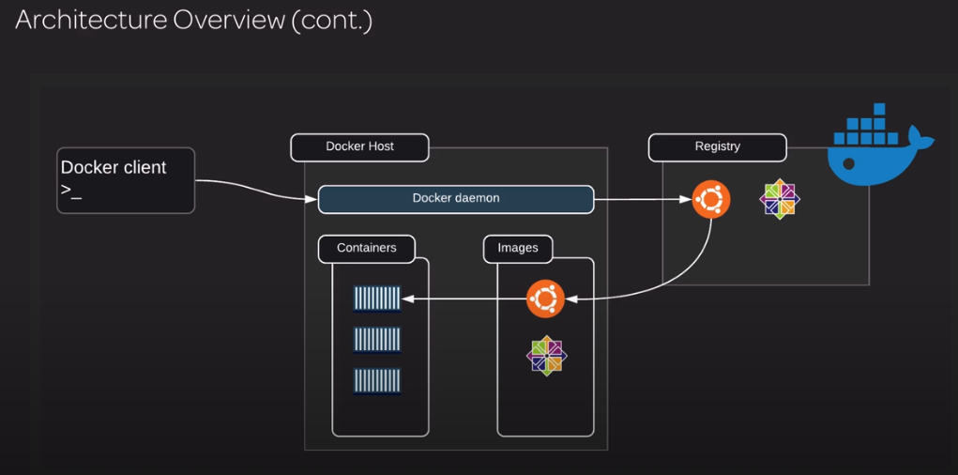

Docker objects:
- Images
- Containers
- Services

Docker Images and Containers
An image is like a class and the container is an instance of that image.
A container is a standard unit of software that packages up code and all its dependencies so the application runs quickly and reliably from one computing environment to another.

Docker Basics

Docker commands

Afin de voir toutes les commandes tu tapes: docker --help
Si c’est pour avoir de l’aide sur une commande spécifique tu tapes par exemple: docker images --help

Afficher en ligne de commande la page du serveur nginx
docker run -d -p 8080:80 --name=web nginx
Puis tu tapes: curl localhost:8080

Management Commands:
- builder Manage builds
- config Manage Docker configs
- container Manage containers
- engine Manage the docker engine
- image Manage images
- network Manage networks
- node Manage Swarm nodes
- plugin Manage plugins
- secret Manage Docker secrets
- service Manage services
- stack Manage Docker stacks
- swarm Manage Swarm
- system Manage Docker
- trust Manage trust on Docker images
- volume Manage volumes
docker image:
- build Build an image from a dockerfile
- history Show the history of an image
- import Import the contents from a tarball to create a filesystem image
- inspect Display detailed information on one or more images
- load Load an image from a tar file or STDIN
- ls List images
- prune Remove unused images
- pull Pull an image or a repository from a registry
- push Push an image or a repository to a registry
- rm Remove one or more images
- save Save one or more images to a tar file (streamed to STDOUT by default)
- tag Create a tag TARGET_IMAGE that refers to SOURCE_IMAGE
docker container:
- attach Attach local standard input, output, and error streams to a running container
- commit Create a new image from a container's changes
- cp Copy files/folders between a container and the local filesystem
- create Create a new container
- diff Inspect changes to files or directories on a container's filesystem
- exec Run a command in a running container
- export Export a container's filesystem as a tar archive
- inspect Display detailed information on one or more containers
- kill Kill one or more running containers
- logs Fetch the logs of a container
- ls List containers
- pause Pause all processes within one or more containers
- port List port mappings or a specific mapping for the container
- prune Remove all stopped containers
- rename Rename a container
- restart Restart one or more containers
- rm Remove one or more containers
- run Run a command in a new container
- start Start one or more stopped containers
- stats Display a live stream of container(s) resource usage statistics
- stop Stop one or more running containers
- top Display the running processes of a container
- unpause Unpause all processes within one or more containers
- update Update configuration of one or more containers
- wait Block until one or more containers stop, then print their exit codes

Voir les logs du container intitulé web:
docker logs web
docker stats web : Pour voir les stats, CPU, mémoire etc..
Pour récupérer la main tape CTRL + C

rm: Remove a container
La commande rm fonctionne sur un container arrêté, s’il est actif il faut ajouter –f pour forcer la fermeture.

Creating Containers
In this lesson, we will take a deeper look into creating containers, by exploring a few of the flags that will alter his behavior when created.
docker container run:
- --help Print usage
- --rm Automatically remove the container when it exits
- -d, --detach Run container in background and print container ID
- -i, --interactive Keep STDIN open even if not attached
- --name string Assign a name to the container
- -p, --publish list Publish a container's port(s) to the host
- -t, --tty Allocate a pseudo-TTY
- -v, --volume list Mount a volume (the bind type of mount)
- --mount mount Attach a filesystem mount to the container
- --network string Connect a container to a network (default "default")
Create a container and attach to it:
docker container run –it busybox

Si tu lance un container avec un simple docker run nginx par exemple, il sera mis en premier plan et tu n’auras donc plus la main sur ton shell à moins de faire un CTRL + C donc il faut le lancer en background avec l’option –d

Create a container and run it in the background:
docker container run –d nginx

Create a container that you name and run it in the background:
docker container run –d –name myContainer busybox

Exposing and Publishing Container Ports

Building on what we've already learned, this lesson will focus on exposing ports on a container, as well as how to publish them.
Exposing:
- Expose a port or a range of ports
- This does not publish the port
- Use --expose [PORT]
docker container run --expose 1234 [IMAGE]
Publishing:
- Maps a container's port to a host`s port
- -p or --publish publishes a container's port(s) to the host
- -P, or --publish-all publishes all exposed ports to random ports
docker container run -p [HOST_PORT]:[CONTAINER_PORT] [IMAGE]
docker container run -p [HOST_PORT]:[CONTAINER_PORT]/tcp -p [HOST_PORT]:[CONTAINER_PORT]/udp [IMAGE]
docker container run -P
Lists all port mappings or a specific mapping for a container:
docker container port [Container_NAME]

Si tu fais un docker run –d –name=web nginx, il va te créer un port TCP 80 sur le container mais si tu vas sur ton localhost de ton host tu ne verras rien because we don’t have a port mapping set up for the port 80.

Si avec un docker inspect | grep IPAd tu récupères l’adresse IP et fais ensuite un curl xxxxx là tu verras ta page Nginx.
Si tu veux ouvrir un port spécifique tu utilises la commande expose, ex :
docker run -d –expose 3000 nginx
Là tu auras exposé le port 3000 mais il n’est pas mappé.
Là je vais exposer le port 3000 puis le mapper avec le port 80 du host:
docker run -d –expose 3000 –p 80:3000 nginx
Si tu fais un curl localhost:3000 tu n’auras rien car aucun process écoute sur le port 3000
Or si tu le fais avec le port 8080: docker run -d –p 8080:80 nginx
En faisant un curl localhost:8080 tu auras la page nginx

Ouverture des ports sur TCP et UDP
docker run -d –p 8081:80/tcp –p 8081:80/udp nginx
Si tu veux que le port de ton host soit pris automatiquement il faut utiliser -P
docker run -d –P nginx

Afin de connaître tous les ports mappés on tape: docker port NomContainer

Executing Container Commands

There are three different ways to execute commands on containers.
- Dockerfile
- During a Docker run
- Using the exec command
Exec ne fonctionne que sur un conteneur en fonction.
"nginx -g 'daemon of…" correspond au nom du Dockerfile utilisé pour cette image.
J’entre directement dans un conteneur en tapant :
docker run –it –name=web nginx /bin/bash

Si ton conteneur intitulé web a déjà été lancé en background et que tu souhaites entrer dedans alors tape :
docker run exec –it web /bin/bash
Tu peux voir ce qu’il y a dans un dossier spécifique en tapant par exemple :
docker container exec -it [NAME] ls /usr/share/nginx/html/

Docker Logging

In this lesson, you will learn how to view the logs of a container to get vital output of your application. You will also learn about some of the logging best practices of containerized applications.
Pour voir les logs on tape : docker logs NameOfTheContainer
Ex :
Create a container using the weather-app image with a Node.js Application.
docker container run --name weather-app -d -p 80:3000 linuxacademycontent/weather-app
Show information logged by a running container:
docker logs weather-app
Tu auras cette réponse :
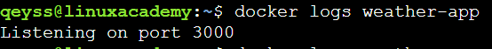
Si ensuite tu vas sur ton IP public tu auras ton application qui te demandes d’entrer le nom d’une ville et te donne sa météo.

Si ensuite tu refais un docker logs weather-app tu verras les logs :

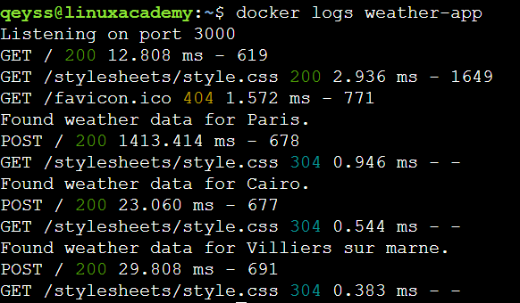
Si tu n’arrives pas à lancer un conteneur, vérifie systématiquement dans ses logs afin de trouver le problème.

Networking

Networking Overview
One of the reasons Docker containers and services are so powerful is that you can connect them together, or connect them to non-Docker workloads. Docker containers and services do not even need to be aware that they are deployed on Docker, or whether their peers are also Docker workloads or not. Whether your Docker hosts run Linux, Windows, or a mix of the two, you can use Docker to manage them in a platform-agnostic way.

Network drivers
Docker’s networking subsystem is pluggable, using drivers. Several drivers exist by default, and provide core networking functionality:
- bridge: The default network driver. If you don’t specify a driver, this is the type of network you are creating. Bridge networks are usually used when your applications run in standalone containers that need to communicate. See bridge networks.
- host: For standalone containers, remove network isolation between the container and the Docker host, and use the host’s networking directly. host is only available for swarm services on Docker 17.06 and higher. See use the host network.
- overlay: Overlay networks connect multiple Docker daemons together and enable swarm services to communicate with each other. You can also use overlay networks to facilitate communication between a swarm service and a standalone container, or between two standalone containers on different Docker daemons. This strategy removes the need to do OS-level routing between these containers. See overlay networks.
- macvlan: Macvlan networks allow you to assign a MAC address to a container, making it appear as a physical device on your network. The Docker daemon routes traffic to containers by their MAC addresses. Using the macvlan driver is sometimes the best choice when dealing with legacy applications that expect to be directly connected to the physical network, rather than routed through the Docker host’s network stack. See Macvlan networks.
- none: For this container, disable all networking. Usually used in conjunction with a custom network driver. none is not available for swarm services. See disable container networking.
- Network plugins: You can install and use third-party network plugins with Docker. These plugins are available from Docker Hub or from third-party vendors. See the vendor’s documentation for installing and using a given network plugin.

Network driver summary
- User-defined bridge networks are best when you need multiple containers to communicate on the same Docker host.
- Host networks are best when the network stack should not be isolated from the Docker host, but you want other aspects of the container to be isolated.
- Overlay networks are best when you need containers running on different Docker hosts to communicate, or when multiple applications work together using swarm services.
- Macvlan networks are best when you are migrating from a VM setup or need your containers to look like physical hosts on your network, each with a unique MAC address.
- Third-party network plugins allow you to integrate Docker with specialized network stacks

Container Network Model
Defines three building blocks:

Sandboxes
Endpoints
Networks

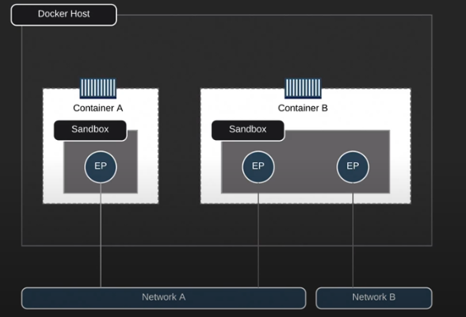

Networking Commands
List all Docker network commands:
docker network -h

List all Docker networks on the host:
docker network ls
docker network ls --no-trunc
Lors de l’installation de Docker, trois réseaux sont créés automatiquement.
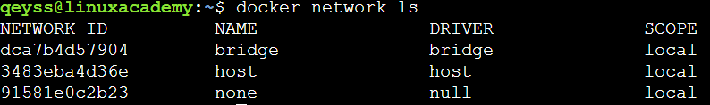

Le réseau Bridge est présent sur tous les hôtes Docker. Lors de la création d’un conteneur, si l’on ne spécifie pas un réseau particulier, les conteneurs sont connectés au Bridge docker0.
La commande ifconfig ou ip a fournit les informations sur le réseau ponté (bridge).

Getting detailed info on a network:
docker network inspect [NAME]
La commande docker network inspect bridge, retourne les informations concernant ce réseau :

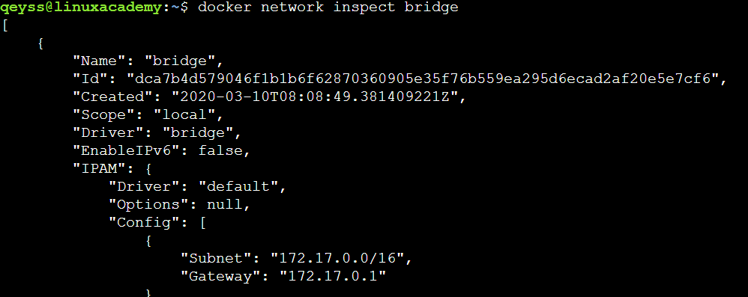

Creating a network:
docker network create br00
Création d’un réseau nommé br00
On l’inspecte :
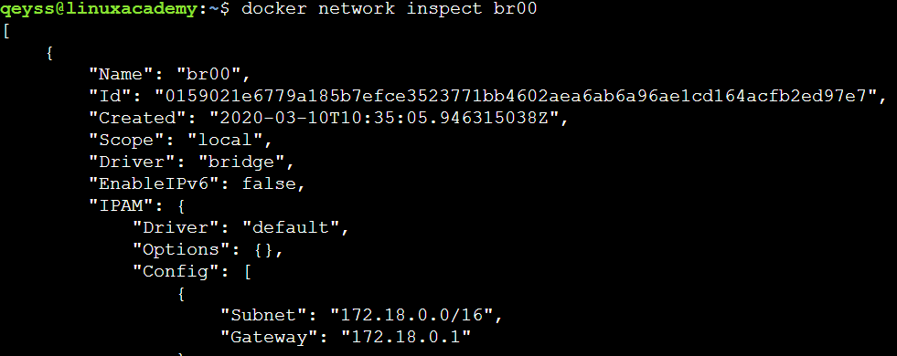
On voit qu’on est bien en local, que le driver par défaut est le bridge et que IPV6 n’est pas actif Le bloc IP attribué au réseau est 172.18.0.0
Deleting a network:
docker network rm [NAME]

Remove all unused networks:
docker network prune

Adding and Removing containers to a network
Create a container with no network:
docker container run -d --name network-test01 -p 8081:80 nginx
Add the container to the bridge network:
docker network connect br00 network-test01
Inspect network-test01 to see the networks:
docker container inspect network-test01
Là tu verras qu’il est attaché au réseau br00 mais aussi au réseau bridge
Remove network-test01 from br00:
docker network disconnect br00 network-test01

Networking Containers

In this lesson, we will dig deeper into container networking by supplying our own subnet and gateway when creating a new network. We will then move on to networking two different containers using an internal network. This will allow one container to be publicly accessible while the other one is not.

Creating a network and defining a Subnet and Gateway
Create a bridge network with a subnet and gateway:
docker network create --subnet 10.1.0.0/24 --gateway 10.1.0.1 br02

Il faut bien s’assurer de prendre une plage d’IP privées.
Run ifconfig to view the bridge interface for br02:
ifconfig
Inspect the br02 network:
docker network inspect br02
Prune all unused networks:
docker network prune

Avant de supprimer faut s’assurer qu’aucun conteneur est en fonction, sinon on le stop ou alors on le supprime directement avec docker rm NOM –f
Si tu ne mets pas le –f il te dira qu’il ne peut supprimer un conteneur en fonction.
Create a network with an IP range:
docker network create --subnet 10.1.0.0/16 --gateway 10.1.0.1 \
--ip-range=10.1.4.0/24 --driver=bridge --label=host4network br04
Inspect the br04 network:
docker network inspect br04
Create a container using the br04 network:
docker container run --name network-test01 -it --network br04 centos /bin/bash
Install Net Tools:
yum update -y
yum install -y net-tools
Get the IP info for the container:
ifconfig
Get the gateway info the container:
netstat -rn
Get the DNS info for the container:
cat /etc/resolv.conf

Assigning IPs to a container:
Create a new container and assign an IP to it:
docker container run -d --name network-test02 --ip 10.1.4.102 --network br04 nginx
Get the IP info for the container:
docker container inspect network-test02 | grep IPAddr
Inspect network-test03 to see that br01 was removed:
docker container inspect network-test04

Networking two containers
Create an internal network:
docker network create -d bridge --internal localhost
Create a MySQL container that is connected to localhost:
docker container run -d --name test_mysql \
-e MYSQL_ROOT_PASSWORD=P4sSw0rd0 \
--network localhost mysql:5.7
Create a container that can ping the MySQL container:
docker container run -it --name ping-mysql \
--network bridge \
centos
Connect ping-mysql to the localhost network:
docker network connect localhost ping-mysql
Restart and attach to container:
docker container start -ia ping-mysql
Create a container that can't ping the MySQL container:
docker container run -it --name cant-ping-mysql \
centos
Create a Nginx container that is not publicly accessible:
docker container run -d --name private-nginx -p 8081:80 --network localhost nginx
Inspect private-nginx:
docker container inspect private-nginx

Dockerfile

Introduction to the Dockerfile

What is the Dockerfile?
Dockerfiles are instructions. They contains all of the commands used to build an image.
- Docker images consist of read-only layers.
- Each represents a Dockerfile instruction.
- Layers are stacked.
- Each layer is a result of the changes from the previous layer.
- Images are built using the docker image build command.

Un example de Dockerfile:
FROM ubuntu:15.04
COPY . /app
RUN make /app
CMD python /app/app.py
Explications :
- FROM creates a layer from the ubuntu:15.04 Docker image.
- COPY adds files from your Docker client’s current directory.
- RUN builds your application with make.
- CMD specifies what command to run within the container.

Working with Instructions

FROM: Initializes a new build stage and sets the Base Image
RUN: Will execute any commands in a new layer
CMD: Provides a default for an executing container. There can only be one CMD instruction in a Dockerfile
LABEL: Adds metadata to an image
EXPOSE: Informs Docker that the container listens on the specified network ports at runtime
ENV: Sets the environment variable <key> to the value <value>
ADD: Copies new files, directories or remote file URLs from <src> and adds them to the filesystem of the image at the path <dest>.
COPY: Copies new files or directories from <src> and adds them to the filesystem of the container at the path <dest>.
ENTRYPOINT: Allows for configuring a container that will run as an executable
VOLUME: Creates a mount point with the specified name and marks it as holding externally mounted volumes from native host or other containers
USER: Sets the user name (or UID) and optionally the user group (or GID) to use when running the image and for any RUN, CMD, and ENTRYPOINT instructions that follow it in the Dockerfile
WORKDIR: Sets the working directory for any RUN, CMD, ENTRYPOINT, COPY, and ADD instructions that follow it in the Dockerfile
ARG: Defines a variable that users can pass at build-time to the builder with the docker build command, using the --build-arg <varname>=<value> flag
ONBUILD: Adds a trigger instruction to the image that will be executed at a later time, when the image is used as the base for another build
HEALTHCHECK: Tells Docker how to test a container to check that it is still working
SHELL: Allows the default shell used for the shell form of commands to be overridden
To set up the environment:
sudo yum install git -y
mkdir docker_images
cd docker_images
mkdir weather-app
cd weather-app
git clone https://github.com/linuxacademy/content-weather-app.git src
Create the Dockerfile:
vi Dockerfile
Dockerfile contents:
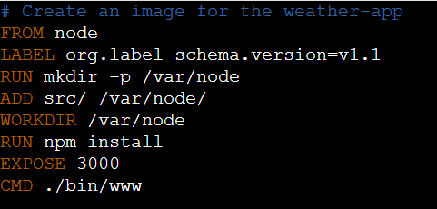

ADD src/ /var/node → Va copier ce qu’il y a dans src dans /var/node
WORKDIR /var/node → Tous les RUN, CMD, ENTRYPOINT, COPY and ADD qui viendront à la suite seront exécutés dans ce dossier spécifié.
CMD → Indique la première commande qui sera exécutée quand le conteneur sera lancé, à placer à la fin.

Build the weather-app image:
docker image build -t linuxacademy/weather-app:v1 .
Les : séparent le nom du tag
List the images:
docker image ls
Create the weather-app container:
docker container run -d --name weather-app1 -p 8081:3000 linuxacademy/weather-app:v1
List all running containers:
docker container ls

Pour voir tu tapes : curl localhost 8081

Environment Variables

Build Arguments
Working with Non-privileged User
Order of Execution

